US History RIO Unit 10 Study Guide: The U.S. since 1968

The 1970s
- What effect did Presidential scandals such as Watergate and Iran-Contra have on the public’s perception of the President?

- What were the SALT talks?

President Carter’s Administration
- In what way are Jimmy Carter and Ronald Reagan considered to be different from the presidential candidates before them?

- What was Carter’s main concern in foreign policy?

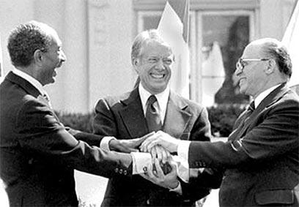
- What things did he do to promote this approach?

- Why are the Camp David Accords considered to be one of the most important events in President Carter’s administration?

- What national crisis is believed the have cost Jimmy Carter re-election?

President Reagan’s Administration
- What was the New Right that came about during the Reagan Era?

- What is another term for “Reaganomics?”

- What is the theory behind Reagan’s economic policy?

- In what area did Reagan increase spending?

- How did the increase in spending in the 1980s affect the national debt?

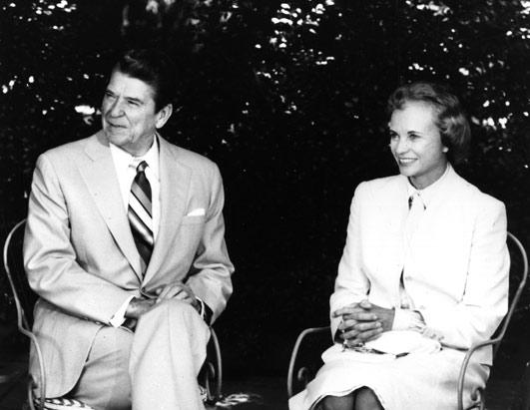
- Why was Reagan’s appointment of Sandra Day O’Connor to the Supreme Court significant?

- What event is considered to mark the start of the fall of Communism?

President George H.W. Bush’s Administration
- Why did the US invade Panama in 1989?

- What happened in Tiananmen Square in 1989?

- What was the main reason the United States went to war against Iraq in 1991?

The Persian Gulf War
- Who was the American general in charge of the troops during Operation Desert Strom?

- What was the outcome of the war?

President Clinton’s Administration
- What was the main objection to the passage of the North American Free Trade Agreement (NAFTA)?

- What events showed the United States became more involved in foreign affairs during Clinton’s presidency?

- What were the formal charges that resulted in Bill Clinton’s impeachment?

Domestic Issues since 1968
- What has been the main goal of the women’s movement over the last thirty years?

- What is affirmative action?

- What has been the main goal of the United States’ immigration policy?

- What happened during the Oklahoma City bombing?

- How was the election of 2000 ultimately decided?

- What cabinet post was created after September 11th 2001?

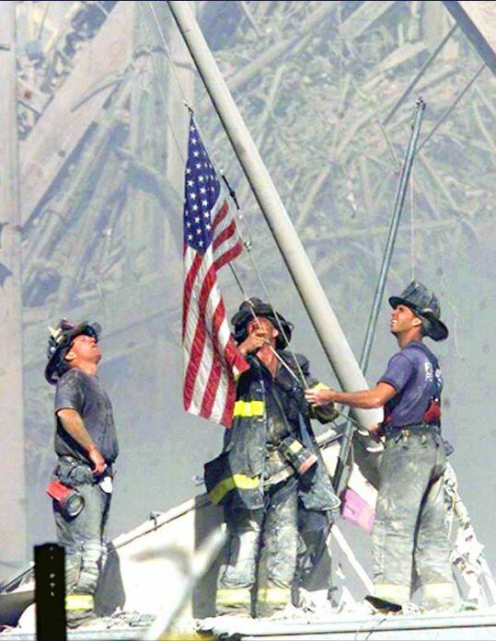
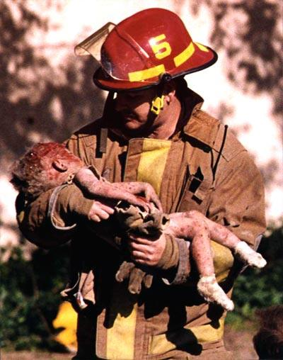
These two photographs are the iconic images of the Oklahoma City Bombing (left) and the terrorist attacks of September 11th (right). How does each one capture the mood of the event it represents? How are the photos alike? How are the different?

